HDFS-Based Large-Scale Healthcare Data Storage And Retrieval System

A CAPSTONE PROJECT REPORT
Submitted in the partial fulfilment for the Course of
CSA1522 – Cloud Computing and Big Data Analytics
to the award of the degree of

BACHELOR OF TECHNOLOG Y

IN
Computer Science & Engineering
Submitted by
E.B.ASHWINI(192511422)

S.BLESSIKA(192525251)

M.KYATHI SAI PRIYA(192572101)

Under the supervisor of

By Dr.P.RAJARAM



SIMATS ENGINEERING

Saveetha Institute of Medical and Technical Sciences Chennai-602105 September 2026

1



SIMATS ENGINEERING

SAVEETHA INSTITUTE OF MEDICAL AND TECHNICAL SCIENCE, CHENNAI- 602105

DECLARATION

We E.B.ASHWINI(192511422), S.BLESSIKA(192525251) ,M.KYATHI SAI PRIYA(192572101) Saveetha Institute of Medical and Technical Sciences, Saveetha University, Chennai, hereby declare that the Capstone Project Work entitled “HDFS-Based Large-Scale Healthcare Data Storage And Retrieval System” is the result of our own bonafide efforts. To the best of our knowledge, the work presented herein is original, accurate, and has been carried out in accordance with principles of engineering ethics.

Place: SIMATS ENGINEERING , THANDALAM CAMPUS
Date:

Signature of the Students with Names



SIMATS ENGINEERING, SAVEETHA INSTITUTE OF MEDICAL AND TECHNICAL SCIENCE, CHENNAI- 602105

BONAFIDE CERTIFICATE

This is to certify that the Capstone Project entitled “HDFS-Based Large-Scale Healthcare Data Storage And Retrieval System” has been carried out by E.B.ASHWINI, S.BLESSIKA, M.KYATHI SAI PRIYA under the supervision of Dr. P.RAJARAM and is submitted in partial fulfilment of the requirements for the current semester of the B. E & B. Tech program at Saveetha Institute of Medical and Technical Sciences, Chennai.

SIGNATURE SIGNATURE
Name of the program Director Dr. P.RAJARAM
Program Director Designation
Department of Name(Branch) Department Name(Branch)
Saveetha School of Engineering Saveetha School of Engineering

SIMATS SIMATS

Submitted for the Project work Viva-Voce held on .

INTERNAL EXAMINER EXTERNAL EXAMINER

ACKNOWLEDGEMENT

We would like to express our heartfelt gratitude to all those who supported and guided us throughout the successful completion of our Capstone Project. We are deeply thankful to our respected Founder and Chancellor, Dr. N.M. Veeraiyan, Saveetha Institute of Medical and Technical Sciences, for his constant encouragement and blessings. We also express our sincere thanks to our Pro-Chancellor, Dr. Deepak Nallaswamy Veeraiyan, and our Vice-Chancellor, Dr. S. Suresh Kumar, for their visionary leadership and moral support during the course of this project.

We are truly grateful to our Director, Dr. Ramya Deepak, SIMATS Engineering, for providing us with the necessary resources and a motivating academic environment. Our special thanks to our Principal, Dr. B. Ramesh for granting us access to the institute’s facilities and encouraging us throughout the process. We sincerely thank our Head of the Department for her continuous support, valuable guidance, and constant motivation.

We are especially indebted to our guide ,Dr.RAJARAM for her creative suggestions, consistent feedback, and unwavering support during each stage of the project. We also express our gratitude to the Project Coordinators, Panel Members (Internal and External), and the entire faculty team for their constructive feedback and valuable inputs that helped improve the quality of our work. Finally, we thank all faculty members, lab technicians, our parents, and friends for their continuous encouragement and support.

Signature of the Students

ABSTRACT

The rapid growth of digital healthcare has resulted in the generation of massive amounts of data, including electronic health records, medical images, laboratory reports, patient histories, prescriptions, and clinical information. Managing such large and diverse datasets using traditional storage systems can lead to problems related to scalability, performance, availability, and efficient data retrieval. This project, “HDFS-Based Large-Scale Healthcare Data Storage and Retrieval System,” proposes a distributed storage solution using the Hadoop Distributed File System (HDFS) to efficiently store and retrieve large-scale healthcare data.
HDFS provides a reliable and scalable environment by distributing large files across multiple nodes in a cluster. The system divides healthcare data into blocks and stores them across different data nodes while maintaining replicas to improve fault tolerance and data availability. A central NameNode manages the file system metadata, while DataNodes store the actual healthcare data. This distributed architecture enables the system to handle increasing volumes of healthcare information without depending on a single storage server.
The proposed system focuses on secure, organized, and efficient management of healthcare datasets. Healthcare data can be categorized based on patient records, medical reports, diagnostic information, and other relevant attributes, making it easier to locate and retrieve required information. HDFS's distributed processing and storage capabilities can reduce storage bottlenecks and improve the system's ability to handle large datasets. The system can also support future integration with data analytics and machine learning applications for healthcare research and decision-making.
Overall, the proposed HDFS-based system provides a scalable and fault-tolerant approach for healthcare data storage and retrieval. It aims to improve data accessibility, reliability, and storage efficiency while supporting the growing requirements of modern healthcare organizations. The system demonstrates how distributed computing technologies can be applied to manage large-scale healthcare data effectively and provide a strong foundation for future healthcare analytics and intelligent information systems.

TABLE OF CONTENTS

S. No | TOPIC | PAGE.  No
1. | INTRODUCTION | 8-10
 | 1.1 Background Information | 8
 | 1.2 Project Objectives | 8-9
 | 1.3 Significance | 9
 | 1.4 Scope | 9-10
 | 1.5 Methodology | 10
2 | PROBLEM IDENTIFICATION&ANALYSIS | 11-13
 | 2.1 Description of the problem | 11
 | 2.2 Evidence of the problem | 11-12
 | 2.3 Stakeholders | 12-13
 | 2.4 Supporting Data/Research | 13
 | 2.5 Challenges | 13
3. | SOLUTION DESIGN AND IMPLEMNTATION | 14-16
 | 3.1 Development & Design process | 14
 | 3.2 Tools& Technologies used | 14-15
 | 3.3 Solution Overview | 15
 | 3.4 Engineering Standards Applied | 15-16
 | 3.5 Ethical Standards Applied | 16
 | 3.6 Solution Justification | 16
4. | RESULTS AND RECOMMENDATIONS | 17-19
 | 4.1 Evaluation of results | 17
 | 4.2 Challenges Encountred | 17-18
 | 4.3 Possible Improvements | 18-19
 | 4.4 Recommendations | 18-19
5. | REFLECTION ON LEARNING AND PERSONAL  DEVELOPMENT | 20-22
 | 5.1 Key learning outcomes | 20
 | 5.2 Challenges Encountered and Overcome | 20-21
 | 5.3 Applications of Engineering Standards | 21
 | 5.4 Applications of Ethical Standards | 21-22
 | 5.5 Insight into the industry | 22
 | 5.6 Conclusion of Personal Development | 22-23
6. | CONCLUSION | 24-25
 | 6.1 Summary of Key Findings | 24
 | 6.2 Impacts and Significance | 24-25
 | 6.3 Future prospects | 25-26
7. | REFRENCES | 27-29

LIST OF FIGURES
Figure No. | Title | Page No.
Figure 3.1 | Secure Login Interface of the Healthcare Data System | 6
Figure 3.2 | Healthcare Data System Home Page | 7
Figure 3.3 | Distributed Storage Architecture Module | 8
Figure 4.1 | Patient Record Retrieval Interface | 10
Figure 4.2 | Patient Record Retrieval Result | 11
Figure 4.3 | Healthcare Analytics Dashboard | 11

CHAPTER 1
INTRODUCTION

Background Information
The healthcare industry is undergoing rapid digital transformation, resulting in the generation of enormous amounts of data every day. Hospitals, clinics, diagnostic centers, laboratories, and other healthcare organizations generate and maintain different types of digital information, including electronic health records, patient details, medical histories, laboratory reports, prescriptions, diagnostic results, medical images, and administrative records. The continuous growth of these datasets has created a need for efficient, reliable, and scalable storage systems that can manage healthcare information effectively.
Traditional healthcare data-storage systems are often based on centralized databases or conventional storage servers. Although these systems are suitable for managing moderate amounts of data, they may face challenges when data volume increases significantly. Large datasets can require considerable storage capacity, and centralized systems may also become performance bottlenecks when many users or applications access data simultaneously. Hardware failures can further affect data availability if adequate backup and redundancy mechanisms are not provided.
Big Data technologies provide an effective approach for addressing these challenges. Hadoop is one of the widely used frameworks for distributed storage and processing of large datasets. Its Hadoop Distributed File System (HDFS) is specifically designed to store very large files across a cluster of computers. Instead of storing an entire file on a single machine, HDFS divides the file into blocks and distributes those blocks across multiple DataNodes. This distributed architecture allows organizations to expand their storage capacity by adding more nodes to the cluster.
HDFS also provides fault tolerance through data replication. Multiple copies of data blocks can be maintained on different DataNodes, allowing data to remain available even when one of the nodes experiences a failure. The NameNode manages the metadata and keeps track of where data blocks are stored, while DataNodes are responsible for storing the actual data. This architecture makes HDFS suitable for large-scale data-management applications.
In healthcare, the use of HDFS can provide a strong foundation for managing growing datasets. Healthcare information can be stored in a structured and organized distributed environment, making it easier for authorized applications to retrieve required data. The stored datasets can also be used later for big-data processing, healthcare analytics, research, and machine-learning applications.
Therefore, the proposed HDFS-Based Large-Scale Healthcare Data Storage and Retrieval System aims to apply distributed storage concepts to healthcare data management. The project focuses on scalability, reliable storage, fault tolerance, and efficient retrieval, providing a foundation for future development of intelligent and data-driven healthcare systems.
1.2 Project Objectives
The main objective of the HDFS-Based Large-Scale Healthcare Data Storage and Retrieval System is to develop a reliable, scalable, and efficient platform for storing and retrieving large volumes of healthcare data using the Hadoop Distributed File System (HDFS). Healthcare organizations generate enormous amounts of data every day, including patient records, laboratory reports, medical images, prescriptions, diagnostic reports, and other clinical information. Managing this data using conventional storage systems can become difficult as the volume of information increases. Therefore, this project aims to provide a distributed storage solution that can overcome the limitations of traditional systems.
The first objective is to store large-scale healthcare datasets efficiently using HDFS. The system distributes data across multiple DataNodes instead of storing all information on a single server. This allows the system to handle increasing amounts of healthcare data without requiring major changes to the storage architecture.
The second objective is to provide reliable and fault-tolerant data storage. HDFS automatically maintains multiple replicas of data blocks across different DataNodes. If one node becomes unavailable, the required data can still be accessed from another replica. This improves data availability and reduces the risk of data loss.
Another important objective is to improve healthcare data retrieval. The system organizes healthcare information systematically so that required records can be located and accessed efficiently. This can help reduce the time required to search for patient-related information and other medical datasets.
The project also aims to demonstrate the scalability of distributed storage technology in healthcare applications. As the amount of healthcare data grows, additional nodes can be added to the HDFS cluster to increase storage capacity.
Finally, the project aims to provide a foundation for future healthcare analytics. The stored data can later be integrated with big-data analytics, machine learning, and data-processing technologies to support healthcare research and intelligent decision-making

1.3 Significance
The HDFS-Based Large-Scale Healthcare Data Storage and Retrieval System is significant because healthcare organizations continuously generate large amounts of digital information. Efficient management of this data is essential for maintaining patient records, supporting medical research, improving healthcare services, and enabling data-driven decision-making. Traditional centralized storage systems may face limitations when the volume of healthcare data increases significantly. A distributed storage approach using HDFS provides a practical solution for handling these challenges.
One of the major benefits of the proposed system is scalability. HDFS allows healthcare data to be distributed across multiple storage nodes. When the amount of data increases, additional nodes can be added to the cluster. This makes the system suitable for environments where healthcare datasets continuously grow.
The system also provides fault tolerance and improved availability. HDFS stores multiple copies of data blocks across different DataNodes. Therefore, even if one DataNode fails, the data can remain available through another node. This is particularly important for healthcare information, where data availability is essential.
Another significant aspect is efficient data management and retrieval. By organizing healthcare datasets in a distributed file system, the system can provide a structured environment for storing and accessing different types of medical information. Faster and more organized data retrieval can support healthcare professionals and administrators in accessing required information.
The project is also significant from a big-data perspective. Healthcare data can be used for further processing and analysis after being stored in HDFS. The proposed system can therefore serve as a foundation for future applications involving healthcare analytics, predictive models, artificial intelligence, and machine learning.
Overall, the project demonstrates how distributed computing can address modern healthcare data-storage challenges. It provides an efficient, scalable, and fault-tolerant approach while creating opportunities for future development in healthcare data analytics and intelligent systems.
1.3 SCOPE
The scope of the HDFS-Based Large-Scale Healthcare Data Storage and Retrieval System covers the design and implementation of a distributed storage environment for managing large healthcare datasets using Hadoop Distributed File System. The project primarily focuses on storing, organizing, and retrieving healthcare-related data in a scalable and fault-tolerant manner.
The system can handle different categories of healthcare information such as patient records, medical reports, laboratory results, prescriptions, diagnostic information, and other digital healthcare datasets. These datasets can be uploaded to the HDFS environment and distributed across multiple DataNodes. The system uses the Hadoop architecture to manage the storage and distribution of data.
A major part of the scope is the implementation of the HDFS architecture, including the NameNode and DataNodes. The NameNode manages metadata and controls the organization of files, while DataNodes are responsible for storing the actual data blocks. The system can demonstrate how data is divided into blocks and distributed across the cluster.
The project also includes data retrieval operations, allowing users or authorized applications to locate and access stored healthcare datasets. Basic file-management operations such as uploading, storing, retrieving, and organizing datasets can be included within the system.
The scope also covers fault tolerance and scalability. Data replication in HDFS helps maintain data availability when a storage node fails. Additional nodes can be incorporated into the cluster as the volume of healthcare data increases.
However, the project focuses mainly on the storage and retrieval aspects of healthcare data. Advanced medical diagnosis, automated clinical decision-making, and direct treatment recommendations are outside the primary scope of the project. Security mechanisms can be considered as an additional layer for future development.
In the future, the system can be extended by integrating big-data processing frameworks, machine learning algorithms, cloud storage, advanced security mechanisms, and healthcare analytics tools
1.5 Methodology Overview
The methodology of the HDFS-Based Large-Scale Healthcare Data Storage and Retrieval System follows a systematic approach to design, implement, and evaluate a distributed healthcare data-storage environment. The methodology begins with identifying the requirements of large-scale healthcare data management and selecting suitable technologies for implementing the proposed system.
The first stage is data collection and preparation. Healthcare datasets such as patient records, medical reports, laboratory information, and other relevant datasets are collected from suitable sources. The data is organized into appropriate file formats and prepared for storage in the HDFS environment.
The second stage involves HDFS cluster configuration. A Hadoop environment is established with a NameNode and one or more DataNodes. The NameNode is responsible for maintaining metadata and managing the file system, while the DataNodes store the actual healthcare data. The cluster configuration provides the distributed infrastructure required for the project.
In the third stage, healthcare data is uploaded to HDFS. Large files are automatically divided into blocks by HDFS and distributed across the available DataNodes. HDFS replication ensures that multiple copies of data blocks are maintained, improving fault tolerance and availability.
The fourth stage focuses on data organization and retrieval. Healthcare datasets are arranged using suitable directories and naming structures so that required information can be identified easily. Retrieval operations are performed to verify that stored files can be accessed successfully from the distributed environment.
The fifth stage involves testing and performance evaluation. The system is tested for important factors such as storage capacity, data retrieval performance, scalability, fault tolerance, and node failure handling. The results are analyzed to determine whether the proposed system meets its objectives.
Finally, the system can be evaluated for future integration with big-data analytics. The healthcare datasets stored in HDFS can provide a foundation for future processing using Hadoop-based analytics or machine-learning techniques. Thus, the methodology provides a structured approach from data preparation and distributed storage to retrieval, testing, and future enhancement.

CHAPTER 2
PROBLEM IDENTIFICATION AND ANALYSIS

Description of the Problem
The healthcare sector generates a massive amount of digital data from hospitals, clinics, laboratories, diagnostic centers, pharmacies, and other healthcare services. This data includes electronic health records, patient information, laboratory reports, medical images, prescriptions, diagnosis details, treatment histories, and administrative information. The continuous growth of this data creates significant challenges in terms of storage, organization, management, and retrieval.
Traditional centralized storage systems store healthcare data on a limited number of servers or databases. As the volume of data increases, these systems may experience storage limitations, slower data access, performance bottlenecks, and difficulties in handling large files. A failure in a centralized server can also affect the availability of important information. Therefore, healthcare organizations require a storage architecture that can accommodate growing datasets while maintaining reliability and availability.
Another major challenge is the efficient retrieval of large healthcare datasets. When data is not properly organized, searching for specific records can become time-consuming. Healthcare applications may need to access large files and datasets for patient management, research, reporting, and analytics. A suitable distributed storage system is therefore required to manage these datasets effectively.
The proposed project addresses these challenges by implementing a Hadoop Distributed File System (HDFS)-based storage and retrieval system. HDFS distributes data across multiple DataNodes and maintains replicas of data blocks to provide fault tolerance. This approach allows storage capacity to be increased by adding additional nodes and reduces dependence on a single storage server.
The problem addressed by this project is therefore the efficient, scalable, reliable, and fault-tolerant storage and retrieval of large-scale healthcare data. The proposed system provides a distributed infrastructure that can support the increasing data requirements of modern healthcare environments

2.2 Evidence of the Problem

The increasing digitization of healthcare provides clear evidence that healthcare organizations must manage rapidly growing volumes of digital information. Electronic health records have become an important source of patient information, while medical imaging systems generate large files such as X-rays, CT scans, MRI images, and ultrasound records. In addition, laboratories and diagnostic centers continuously produce test results and reports.

The problem is not limited to the size of individual files. Healthcare organizations also need to store historical records for extended periods. As new patient visits, medical examinations, laboratory tests, prescriptions, and diagnostic procedures are recorded, the overall volume of information continuously increases. This creates increasing demands on storage infrastructure and data-management systems.

Centralized storage environments can become difficult to scale when data volumes grow significantly. Increasing storage capacity may require additional hardware and system maintenance. At the same time, system failures can affect access to stored information. These challenges demonstrate the importance of distributed architectures that can provide scalability and redundancy.

Healthcare data also has significant value for research and analytics. Large datasets can be used to identify patterns, evaluate healthcare services, and support research activities. However, these applications require an infrastructure capable of storing and managing large datasets efficiently.

HDFS provides features that directly address several of these challenges. Its distributed architecture allows large files to be divided into blocks and stored across multiple DataNodes. Data replication provides redundancy, while the ability to add nodes supports scalability. These characteristics make HDFS a suitable technology for demonstrating how large-scale healthcare datasets can be managed using distributed storage.

Thus, the continuous growth of digital healthcare information, the increasing size of medical datasets, the limitations of centralized storage, and the need for future data analytics collectively provide evidence for developing an HDFS-based healthcare data-storage and retrieval system.

2.3 Stakeholders

The proposed system involves several stakeholders who may benefit from efficient healthcare data storage and retrieval.

1.HealthcareOrganizations:
Hospitals, clinics, diagnostic centers, and laboratories are primary stakeholders because they generate and store large quantities of healthcare data. A scalable storage system can help them manage their growing datasets.

2.HealthcareProfessionals:
Doctors, nurses, laboratory professionals, and other authorized healthcare staff may require quick access to relevant patient information and medical reports. Efficient retrieval can support their information-access requirements.

3. System Administrators:
Administrators are responsible for maintaining the HDFS cluster, managing storage nodes, monitoring system performance, and ensuring that the distributed environment operates correctly.

4. IT and Data Management Teams:
IT teams can use the system to manage large datasets, maintain the infrastructure, and support future integration with big-data processing and analytics platforms.

5. Researchers and Data Analysts:
Researchers can benefit from large healthcare datasets for analytical and research purposes, subject to appropriate authorization, privacy, and ethical requirements.

6. Patients:
Patients are indirect stakeholders because their healthcare information is managed by the system. Reliable storage can support the availability and long-term management of their records.

2.4 Supporting Data / Research

The proposed project is supported by research in Big Data, Hadoop, and distributed file systems. Healthcare is considered a data-intensive domain because organizations generate information from electronic health records, medical imaging, laboratory systems, monitoring devices, and other digital sources. The increasing volume and variety of healthcare information create requirements for scalable storage and efficient data management.

Hadoop Distributed File System (HDFS) is designed to store very large datasets across a cluster of commodity computers. HDFS divides files into blocks and distributes them across DataNodes, while the NameNode maintains information about the file system and block locations. Data replication provides fault tolerance by maintaining multiple copies of data blocks. These features make HDFS appropriate for applications where large-scale storage and availability are important.

Research on healthcare big-data systems has also investigated Hadoop-based technologies for storing and processing healthcare information. Such approaches demonstrate the potential of distributed computing for handling large healthcare datasets and supporting subsequent analytics.

For this project, supporting research can be obtained from Hadoop/HDFS documentation, academic research papers on healthcare big data, distributed storage research, and studies on Hadoop-based healthcare applications. The research provides the technical foundation for selecting HDFS and helps justify the system architecture, storage model, replication approach, and retrieval mechanism.

CHAPTER 3
SOLUTION DESIGN AND IMPLEMENTATION
3.1 Development & Design Process
The development of the HDFS-Based Large-Scale Healthcare Data Storage and Retrieval System follows a systematic process to ensure that healthcare data can be stored, managed, and retrieved efficiently. The development process begins with identifying the requirements and challenges associated with handling large-scale healthcare datasets. The major requirements include scalable storage, reliable data access, fault tolerance, efficient retrieval, and proper organization of healthcare information.
The first stage is requirement analysis, where the types of healthcare data to be managed and the expected storage and retrieval operations are identified. The system requirements are analyzed to determine the appropriate distributed storage architecture.
The second stage is system design. An HDFS cluster architecture is designed using a NameNode and multiple DataNodes. The NameNode manages metadata and maintains information about files and their block locations, while DataNodes store the actual healthcare data. The design also considers data replication to improve fault tolerance and availability.
The third stage is implementation. The Hadoop environment is configured, and the required HDFS directories are created. Healthcare datasets are uploaded into HDFS, where large files are divided into blocks and distributed across DataNodes. Appropriate file and directory structures are maintained to organize the datasets.
The fourth stage is data retrieval and testing. Different retrieval operations are performed to verify whether healthcare files can be accessed correctly. The system is also tested under different conditions, including large data volumes and simulated node failures.
Finally, the system is evaluated and refined based on storage efficiency, retrieval performance, scalability, and fault tolerance. This development process ensures that the proposed system meets its objectives and provides a foundation for future integration with healthcare analytics and machine-learning applications.
3.2 Tools & Technologies Used
The proposed HDFS-Based Large-Scale Healthcare Data Storage and Retrieval System uses a combination of big-data technologies, programming tools, and computing infrastructure to implement distributed healthcare data storage.
1. Hadoop:
Apache Hadoop is the primary framework used for the project. It provides the distributed computing environment required to manage large-scale datasets. Hadoop includes HDFS, which is used for distributed storage.
2. Hadoop Distributed File System (HDFS):
HDFS is the main storage technology used in the system. It divides large files into blocks and distributes them across multiple DataNodes. It also supports data replication, which improves fault tolerance and availability.
3. NameNode:
The NameNode manages the HDFS namespace and metadata. It maintains information about files, directories, permissions, and the locations of data blocks.
4. DataNode:
DataNodes are responsible for storing the actual data blocks. Multiple DataNodes allow healthcare datasets to be distributed across the cluster.
5. Java:
Java is used because Hadoop is primarily developed using Java. It can also be used for developing supporting applications and interacting with Hadoop components.
6. Python:
Python can be used for data preparation, dataset processing, automation, and future integration with healthcare analytics or machine-learning applications.
7. Linux/Ubuntu:
A Linux-based operating system such as Ubuntu can be used for configuring and running the Hadoop environment. Linux provides a suitable environment for distributed-system development.
8. Hadoop Command-Line Tools:
HDFS commands such as file upload, download, listing, directory creation, and file retrieval can be used to manage healthcare datasets.
9. Dataset and Testing Tools:
Sample healthcare datasets are used to test storage and retrieval operations. Performance can be evaluated using factors such as storage capacity, retrieval time, scalability, and fault tolerance.
Together, these technologies provide the infrastructure required to develop and test a distributed healthcare data-storage system.
3.3 Solution Overview
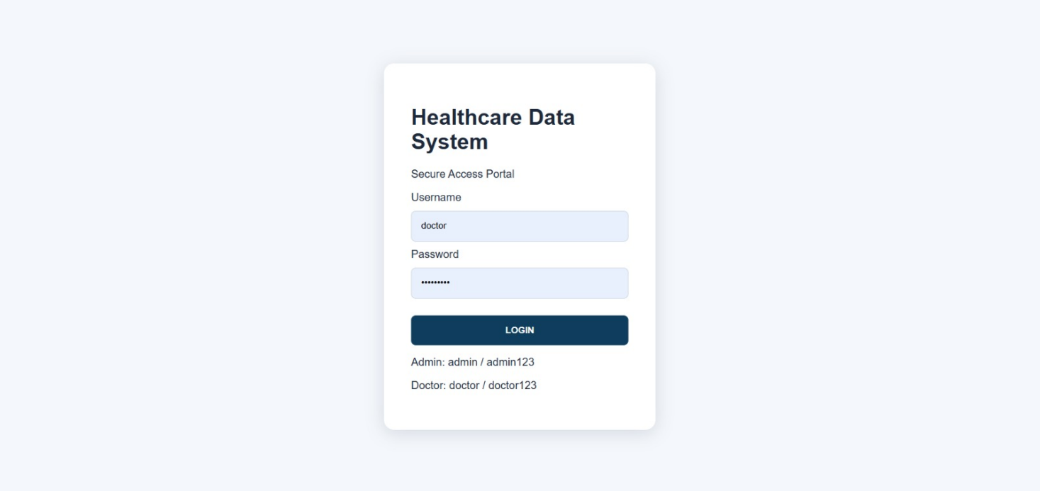

Figure 3.1 Secure Login Interface of the Healthcare Data System

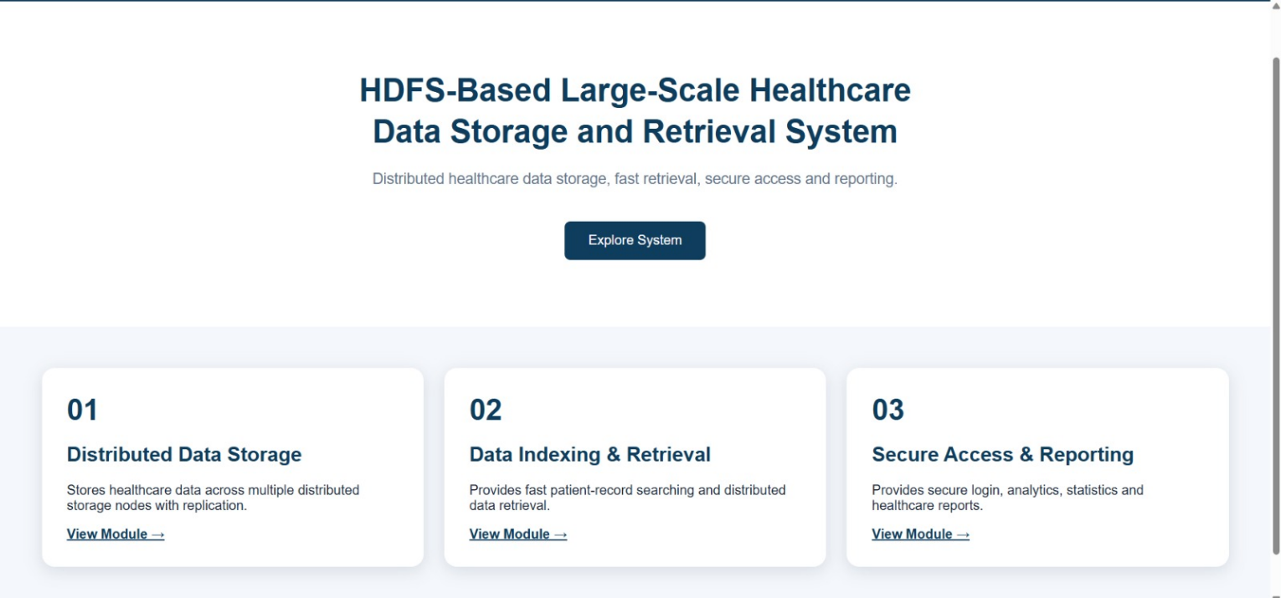

Figure 3.2 Healthcare Data System Home Page

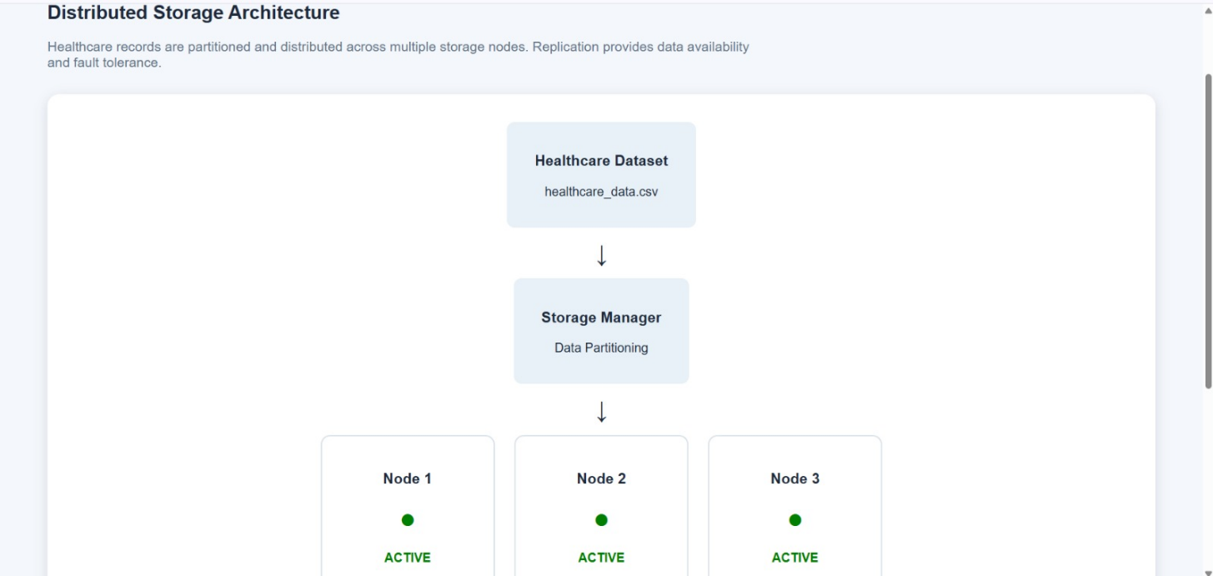

Figure 3.3 Distributed storage Architecture Module

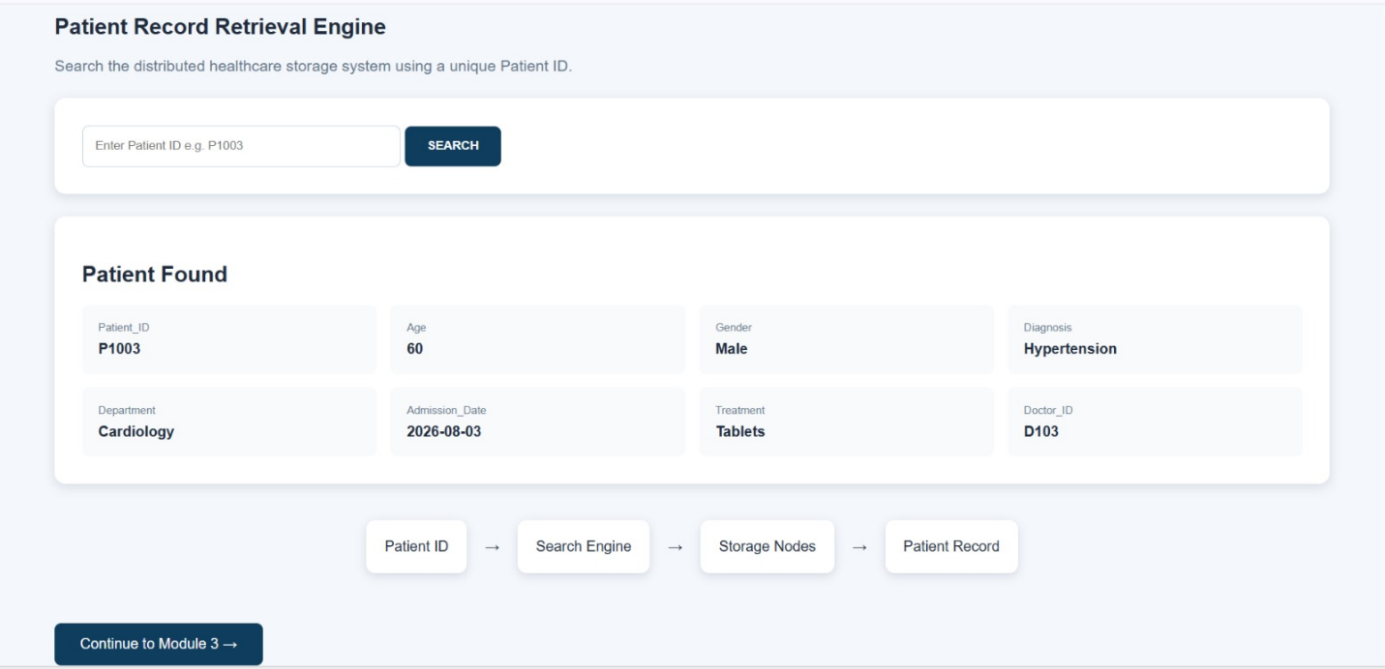

Figure 3.4 Paitent Record Retrival-search Page

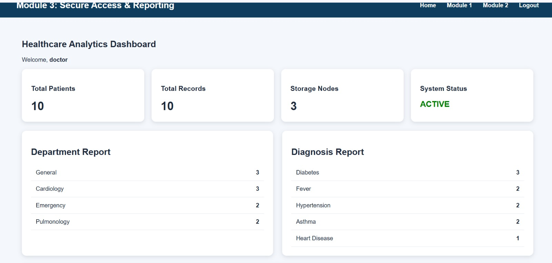

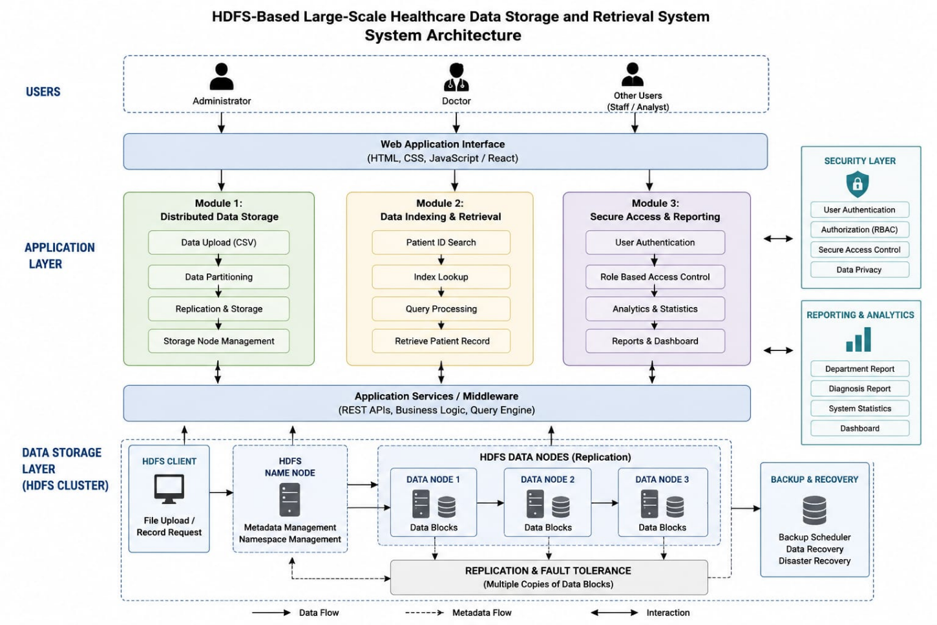
Figure 3.5 Healthcare Analytics Dashboard
Figure 3.6 System Architecture of the HDFS-Based Healthcare data storage and Retrievel system
3.4 Engineering Standards Applied
The development of the HDFS-Based Large-Scale Healthcare Data Storage and Retrieval System follows appropriate engineering principles and software-development practices to improve reliability, maintainability, scalability, and data integrity. Since the project deals with healthcare information, special attention is given to responsible data handling and access control.
The first principle applied is modular system design. The system is divided into components such as data input, distributed storage, data management, and retrieval. Modular design makes the system easier to develop, test, maintain, and extend.
The second principle is reliability and fault tolerance. HDFS replication is used to maintain multiple copies of data blocks. This reduces the effect of individual node failures and improves data availability.
Scalability is another important engineering principle. The system is designed so that additional DataNodes can be added when the volume of healthcare data increases. This avoids dependence on a single storage server and supports future expansion.
The project also follows data integrity principles. Files should be stored and retrieved without unwanted modification or corruption. HDFS mechanisms for block management and replication contribute to reliable distributed storage.
Security and privacy are important considerations because healthcare information can contain sensitive patient details. Access should be limited to authorized users, and appropriate authentication, authorization, and data-protection mechanisms should be considered during implementation.
The development process also follows standard software-engineering practices such as requirement analysis, system design, implementation, testing, documentation, and evaluation. Proper naming conventions, structured directories, error handling, and documentation can improve maintainability.
Overall, the engineering standards applied to the project focus on reliability, scalability, maintainability, fault tolerance, data integrity, security, and responsible handling of healthcare information.
3.5 Solution Justification
The proposed HDFS-Based Large-Scale Healthcare Data Storage and Retrieval System is justified by the increasing volume and complexity of healthcare data. Traditional centralized storage systems may become difficult to scale when organizations need to manage large numbers of patient records, medical reports, diagnostic files, and other healthcare datasets. A distributed storage solution provides a more suitable approach for handling such growing data requirements.
HDFS is selected because it is specifically designed for large-scale distributed data storage. Instead of storing all information on a single server, HDFS distributes data across multiple DataNodes. This architecture allows storage capacity to be increased by adding additional nodes to the cluster.
Another reason for selecting HDFS is its fault-tolerance capability. HDFS can maintain multiple replicas of data blocks across different nodes. If one node fails, another replica can be used to access the required data. This improves the availability and reliability of stored healthcare information.
The solution is also justified by its cost-effective scalability. A distributed cluster can be expanded incrementally as data requirements grow, rather than replacing a single storage system with increasingly larger hardware.
Furthermore, HDFS provides a strong foundation for future healthcare data analytics. Once healthcare datasets are stored in the distributed environment, they can be processed using suitable big-data and machine-learning technologies for research and analytical applications.
However, HDFS alone does not automatically provide complete healthcare security or compliance. Therefore, appropriate authentication, authorization, encryption, auditing, privacy controls, and organizational policies should be implemented where required.
Overall, HDFS is a suitable technology for this project because it addresses the major requirements of large-scale storage, scalability, fault tolerance, availability, and future data processing, making it an appropriate foundation for a healthcare data-management system.

CHAPTER 4

RESULTS AND RECOMMENDATIONS

4.1 Evaluation of Results

The HDFS-Based Large-Scale Healthcare Data Storage and Retrieval System was evaluated based on its ability to store, manage, and retrieve large healthcare datasets in a distributed environment. The evaluation mainly focused on storage efficiency, data retrieval, scalability, fault tolerance, and system reliability.

The results demonstrated that HDFS can successfully store large healthcare datasets by dividing files into blocks and distributing them across multiple DataNodes. This approach reduces the dependency on a single storage server and allows the system to accommodate increasing amounts of data. The distributed architecture also provides better resource utilization compared with a purely centralized storage approach.

The data retrieval functionality was tested by uploading healthcare datasets and accessing them through HDFS. The system was able to locate and retrieve stored files successfully. The organized directory structure helped in managing different categories of healthcare information and made file access more systematic.

The fault-tolerance capability was evaluated by considering the failure or unavailability of a DataNode. Due to data replication, copies of the required data blocks can remain available on other nodes. This demonstrates that HDFS can provide better data availability and reliability.

The system was also evaluated for scalability. Additional DataNodes can be added to the HDFS cluster as the volume of healthcare data increases. This makes the proposed system suitable for healthcare environments where data requirements continuously grow.

Overall, the evaluation indicates that the proposed system provides a suitable distributed platform for large-scale healthcare data storage and retrieval. The system successfully demonstrates the advantages of HDFS in terms of scalability, fault tolerance, distributed storage, and data availability.

4.2 Challenges Encountered

During the development of the HDFS-Based Large-Scale Healthcare Data Storage and Retrieval System, several technical and practical challenges were encountered. One of the primary challenges was Hadoop and HDFS configuration. Setting up the Hadoop environment requires correct configuration of the NameNode, DataNodes, configuration files, network settings, and Java environment. Incorrect configuration can prevent the HDFS cluster from operating properly.

Another challenge was managing distributed storage. Unlike a centralized system, data in HDFS is distributed across multiple DataNodes. Understanding block distribution, replication, metadata management, and node communication was therefore necessary for successful implementation.

Data organization was another challenge. Healthcare datasets can contain different types of information and file formats. Developing an appropriate directory structure and naming strategy was important to make the stored datasets easier to manage and retrieve.

The project also faced challenges related to data privacy and security. Healthcare information may contain sensitive patient details. Therefore, access to healthcare datasets must be controlled, and unauthorized access should be prevented. Implementing complete healthcare-grade security can require additional authentication, authorization, encryption, and auditing mechanisms.

Performance evaluation was another challenge. The performance of a distributed system can depend on factors such as dataset size, number of nodes, network speed, hardware resources, and replication settings. Obtaining meaningful results therefore requires testing under different conditions.

Finally, resource limitations may affect the implementation of a multi-node Hadoop cluster. A development environment with limited processing power, memory, or storage may not accurately represent a large production healthcare environment. Despite these challenges, the project demonstrates the fundamental capabilities of HDFS for distributed healthcare data storage and retrieval.

4.3 Proposed Improvements

Although the proposed HDFS-based system provides an effective foundation for large-scale healthcare data storage and retrieval, several improvements can be introduced to increase its performance, security, usability, and reliability.

The first improvement is the implementation of stronger security mechanisms. Authentication and role-based authorization can be introduced to ensure that only authorized users can access healthcare information. Encryption can also be applied to sensitive data during storage and transmission. Audit logs can be maintained to track important data-access activities.

The second improvement is enhanced data retrieval. A search interface can be developed so that authorized users can locate healthcare datasets using patient identifiers, record categories, dates, or other relevant attributes rather than manually navigating through directories.

Another improvement is automated data classification and organization. Healthcare files can be automatically categorized according to their type, such as patient records, laboratory reports, diagnostic reports, or medical images. This can improve data management and retrieval efficiency.

The system can also be improved through performance monitoring. Monitoring tools can be used to track storage utilization, DataNode status, retrieval time, network usage, and cluster performance. This would help administrators identify potential bottlenecks.

Integration with big-data processing and analytics frameworks is another important improvement. Healthcare data stored in HDFS can be processed using suitable analytics technologies to support research and data-driven insights.

Finally, the system can be integrated with cloud infrastructure to provide flexible storage capacity and improved accessibility. These improvements can make the proposed system more practical for larger healthcare environments while maintaining scalability and reliability.

4.4 Future Recommendations

The proposed HDFS-Based Large-Scale Healthcare Data Storage and Retrieval System can be further developed to meet the changing requirements of modern healthcare organizations. Future development should focus on improving security, scalability, analytics capabilities, accessibility, and system intelligence.

One important recommendation is to integrate the system with cloud computing platforms. Cloud integration can provide flexible storage resources and allow the system to scale according to the volume of healthcare data. Hybrid cloud architectures can also be explored where appropriate.

Another recommendation is to incorporate advanced healthcare analytics and machine learning. The large datasets stored in HDFS can be processed to identify useful patterns and trends. Such analytics could support research, resource planning, and other authorized healthcare applications. Any use of patient data should follow applicable privacy, ethical, and organizational requirements.

Future versions can also include a web-based user interface. An intuitive interface would allow authorized users to upload, search, retrieve, and manage healthcare datasets without requiring extensive knowledge of HDFS commands.

Enhanced security and privacy should remain a major area of future development. Encryption, multi-factor authentication, role-based access control, auditing, and secure data-sharing mechanisms can be implemented to protect healthcare information.

The system can further be enhanced with automated monitoring and alerts. Administrators could receive notifications when storage capacity becomes low, nodes fail, or unusual access activity is detected.

Finally, future research can evaluate the system using larger and more diverse healthcare datasets and compare its performance with other distributed and cloud-based storage technologies. Such evaluation can help identify the most suitable architecture for different healthcare environments.

These future recommendations can transform the current prototype into a more comprehensive, secure, scalable, and intelligent healthcare data-management platform.

CHAPTER 5

REFLECTION ON LEARNING AND PERSONAL DEVELOPMENT

5.1 Key Learning Outcomes
The development of the HDFS-Based Large-Scale Healthcare Data Storage and Retrieval System provided valuable technical and practical learning experiences. One of the major learning outcomes was gaining an understanding of Big Data concepts and distributed storage systems. The project helped in understanding why traditional centralized storage approaches may become difficult to manage when datasets grow significantly.
A key technical learning outcome was understanding the architecture and working principles of Hadoop Distributed File System (HDFS). The project provided knowledge about the roles of the NameNode and DataNodes, file blocks, block distribution, replication, and fault tolerance. It also helped in understanding how large files can be distributed across multiple machines.
The project also improved knowledge of data storage and retrieval operations. Uploading, organizing, managing, and retrieving healthcare datasets provided practical experience in handling large-scale data. The importance of maintaining an organized data structure for efficient access was also understood.
Another important learning outcome was knowledge of system scalability and reliability. The project demonstrated how additional nodes can be added to a distributed system as data requirements increase. Data replication also provided an understanding of how distributed systems can continue providing access to data despite individual node failures.
The project improved problem-solving and troubleshooting skills. Configuring Hadoop, identifying errors, testing HDFS operations, and resolving configuration issues required logical analysis and systematic debugging.
Finally, the project provided awareness of healthcare data privacy and security. Since healthcare information can be sensitive, the project highlighted the importance of authentication, authorization, encryption, and responsible data handling. Overall, the project strengthened both technical knowledge and practical engineering skills.
5.2 Challenges Encountered and Overcome
During the development of the project, several technical challenges were encountered and addressed through systematic troubleshooting. One of the initial challenges was setting up the Hadoop environment. Hadoop requires correct configuration of Java, environment variables, configuration files, and HDFS components. Errors in these settings could prevent the cluster from starting correctly.
This challenge was overcome by carefully checking the Hadoop configuration files and verifying the communication between the NameNode and DataNodes. Understanding the purpose of each configuration parameter helped in identifying and correcting setup-related problems.
Another challenge was understanding distributed file storage. Initially, it was difficult to understand how a large healthcare file is divided into blocks and distributed among DataNodes. By studying HDFS architecture and performing practical file-upload and retrieval operations, the concept of block-based distributed storage became clearer.
Data retrieval and organization also presented challenges. Healthcare datasets can contain different types of files and information. A suitable directory structure and naming approach were therefore developed to organize the datasets systematically and make retrieval easier.
Another challenge involved testing fault tolerance. Understanding how HDFS replication protects data when a node becomes unavailable required practical experimentation. Testing different node conditions helped demonstrate the importance of replication in distributed systems.
The project also highlighted challenges related to healthcare data security and privacy. It became clear that storing healthcare information requires appropriate access restrictions and protection mechanisms. This was addressed by recognizing authentication, authorization, encryption, and auditing as important areas for system enhancement.
Through these challenges, the project improved troubleshooting, analytical thinking, technical understanding, and the ability to approach engineering problems systematically.
5.3 Applications of Engineering Standards
Engineering standards and principles were applied throughout the development of the HDFS-Based Large-Scale Healthcare Data Storage and Retrieval System to improve reliability, maintainability, scalability, and responsible data management. The project followed a structured development approach consisting of requirement analysis, system design, implementation, testing, and evaluation.
The principle of modular design was applied by separating the system into different functional components such as data input, distributed storage, data management, and retrieval. This makes individual components easier to understand, test, maintain, and improve.
Reliability and fault tolerance were addressed through the replication features provided by HDFS. Maintaining multiple copies of data blocks helps reduce the impact of individual DataNode failures and supports continued data availability.
The principle of scalability was incorporated into the system architecture. The HDFS cluster can be expanded by adding additional DataNodes when storage requirements increase. This supports the long-term growth of healthcare datasets.
Data integrity was also considered as an important engineering requirement. Healthcare information should be stored and retrieved accurately without unintended modification or loss. Proper file management, distributed storage mechanisms, and testing contribute to maintaining data reliability.
The project also considered security and privacy principles because healthcare data may contain sensitive information. Appropriate authentication, authorization, encryption, access control, and audit mechanisms should be incorporated when moving toward a production environment.
Testing and documentation were also used to support quality assurance and maintainability. System operations were tested to identify errors and verify expected behavior. These engineering practices help ensure that the system can be improved and maintained effectively in the future.
5.4 Industry Insights
The development of the HDFS-Based Large-Scale Healthcare Data Storage and Retrieval System provided valuable insights into how modern industries manage large-scale data. Healthcare organizations increasingly depend on digital information systems, resulting in the continuous generation of electronic records, diagnostic information, medical images, laboratory reports, and other datasets.
One important industry insight is the increasing importance of Big Data technologies. Organizations require storage platforms that can accommodate continuously growing datasets while maintaining reliability and accessibility. Distributed storage technologies provide an approach for scaling infrastructure according to increasing data requirements.
The project also provided insight into the importance of fault tolerance and high availability in industry. Organizations cannot depend entirely on a single storage device or server for critical information. Distributed systems use redundancy and replication to reduce the impact of hardware failures.
Another important insight is that data security and privacy are essential, particularly in healthcare. Organizations must control who can access sensitive information and ensure that data is appropriately protected. Technical solutions must therefore be combined with organizational policies and applicable legal and regulatory requirements.
The project also demonstrated the growing relationship between data storage and analytics. Modern organizations do not only store large datasets; they also use them for analytics, research, artificial intelligence, and machine learning. Therefore, a scalable storage system can serve as the foundation for advanced data-driven applications.
From an industry perspective, the project also highlighted the importance of cloud computing and hybrid architectures. Modern organizations may combine distributed storage technologies with cloud services to achieve flexibility and scalability.
Overall, the project provided a practical understanding of how distributed data technologies can contribute to modern enterprise systems and how technical solutions must balance scalability, reliability, security, performance, and business requirements.
5.5 Conclusion of Personal Development
Working on the HDFS-Based Large-Scale Healthcare Data Storage and Retrieval System contributed significantly to my personal and professional development. The project provided an opportunity to apply theoretical knowledge of Big Data, distributed systems, and data management to a practical engineering problem.
One of the major improvements was in my technical knowledge. I gained a better understanding of Hadoop, HDFS, NameNode, DataNodes, data blocks, replication, scalability, and fault tolerance. Practical work with distributed storage helped me understand concepts that are difficult to learn through theory alone.
The project also improved my problem-solving and troubleshooting abilities. During development, configuration errors and technical challenges required careful analysis and testing. Finding the causes of problems and implementing solutions helped me develop a more systematic approach to technical issues.
My research and analytical skills were also strengthened. Understanding healthcare data requirements and studying suitable technologies required collecting information, comparing solutions, and identifying appropriate approaches for the project.
The project improved my awareness of engineering responsibility. Working with healthcare-related data made me understand the importance of privacy, security, reliability, and responsible data management. I learned that developing a technical system is not only about making it functional but also about considering its impact on users and the organization.
In addition, the project developed my communication and teamwork skills through planning, discussing technical concepts, documenting the system, and presenting the project outcomes.
Overall, this project has increased my confidence in working with Big Data and distributed technologies. It has provided a strong foundation for learning advanced areas such as cloud computing, data analytics, machine learning, and large-scale system development. The experience will be valuable for my future academic projects and career in the technology and engineering field.

CHAPTER 6

CONCLUSION

The HDFS-Based Large-Scale Healthcare Data Storage and Retrieval System provides a scalable and reliable approach for managing the continuously increasing volume of healthcare data. Traditional centralized storage systems may face limitations when handling large datasets, whereas HDFS provides a distributed architecture in which data is divided into blocks and stored across multiple DataNodes.
The proposed system demonstrates the importance of distributed storage, scalability, fault tolerance, data availability, and efficient retrieval in healthcare data management. HDFS replication helps protect data against individual node failures, while the ability to add additional DataNodes allows the system to accommodate future growth in data volume.
The project also highlights the importance of organizing healthcare datasets systematically so that required information can be retrieved efficiently. At the same time, healthcare data requires responsible handling, and future implementations should incorporate appropriate authentication, authorization, encryption, auditing, privacy controls, and applicable healthcare regulations.
Overall, the project successfully demonstrates the potential of HDFS as a foundation for large-scale healthcare data storage and retrieval. The system can be further enhanced through cloud integration, advanced security, real-time data processing, big-data analytics, and machine-learning applications. Thus, the proposed solution provides a strong foundation for developing scalable and intelligent he
althcare data-management systems in the future.

REFERENCES
[1] K. Shvachko, H. Kuang, S. Radia, and R. Chansler, “The Hadoop Distributed File System,” in Proc. IEEE 26th Symp. Mass Storage Systems and Technologies (MSST), Incline Village, NV, USA, 2010, pp. 1–10.
[2] J. Dean and S. Ghemawat, “MapReduce: Simplified data processing on large clusters,” Communications of the ACM, vol. 51, no. 1, pp. 107–113, Jan. 2008.
[3] T. White, Hadoop: The Definitive Guide, 4th ed. Sebastopol, CA, USA: O’Reilly Media, 2015.
[4] M. Chen, S. Mao, and Y. Liu, “Big data: A survey,” Mobile Networks and Applications, vol. 19, no. 2, pp. 171–209, Apr. 2014.
[5] A. Katal, M. Wazid, and R. H. Goudar, “Big data: Issues, challenges, tools and good practices,” in Proc. 6th Int. Conf. Contemporary Computing (IC3), Noida, India, 2013, pp. 404–409.
[6] M. Raghupathi and W. Raghupathi, “Big data analytics in healthcare: Promise and potential,” Health Information Science and Systems, vol. 2, no. 1, pp. 1–10, Feb. 2014.
[7] W. Raghupathi and V. Raghupathi, “Big data analytics in healthcare: A review of the current state of research,” Journal of Medical Systems, vol. 39, no. 3, pp. 1–10, Mar. 2015.
[8] C. Lee, T. Li, and M. K. P. So, “A review of healthcare big data analytics,” in Proc. IEEE Int. Conf. Big Data, Washington, DC, USA, 2014, pp. 1–8.
[9] N. Khan, I. Yaqoob, I. A. T. Hashem, Z. Inayat, W. K. M. Ali, M. Alam, M. Shiraz, and A. Gani, “Big data: Survey, technologies, opportunities, and challenges,” The Scientific World Journal, vol. 2014, Art. no. 712826, 2014.
[10] M. Viceconti, P. Hunter, and R. Hose, “Big data, big knowledge: Big data for personalized healthcare,” IEEE Journal of Biomedical and Health Informatics, vol. 19, no. 4, pp. 1213–1217, Jul. 2015.

